Year 9 – Do Now Name:_____________________

Match the word with the definition

|  |  |  |  |
| --- | --- | --- | --- |
| Atom |  | a. | The number or protons in an atom. Each element has a unique one of these |
| Neutral particle |  | b. | The smallest particle of an element. They are made up of a nucleus of protons and neutrons, surrounded by a cloud of electrons. |
| Mass number |  | c. | A substance made of only one type of atom |
| Atomic number |  | d. | An atom or molecule with a net charge |
| Neutron |  | e. | A subatomic particle with positive charge |
| Nucleus |  | f. | A subatomic particle with no charge. These are located in the nucleus of the atom |
| Proton |  | g. | The central part of an atom with an overall positive charge |
| Molecule |  | h. | A very small subatomic particle with negative charge. They are located outside the nucleus of an atom. |
| Element |  | i. | The number of protons and neutrons in an atom. Atoms of an element can have more or less neutrons, changing this number. |
| Ion |  | j. | A group of atoms bonded together |
| Electron |  | k. | A particle with zero net charge |

Y ear 9 – Do Now Name:_____________________

Match the word with the definition

|  |  |  |  |
| --- | --- | --- | --- |
| Atom |  | a. | The number or protons in an atom. Each element has a unique one of these |
| Neutral particle |  | b. | The smallest particle of an element. They are made up of a nucleus of protons and neutrons, surrounded by a cloud of electrons. |
| Mass number |  | c. | A substance made of only one type of atom |
| Atomic number |  | d. | An atom or molecule with a net charge |
| Neutron |  | e. | A subatomic particle with positive charge |
| Nucleus |  | f. | A subatomic particle with no charge. These are located in the nucleus of the atom |
| Proton |  | g. | The central part of an atom with an overall positive charge |
| Molecule |  | h. | A very small subatomic particle with negative charge. They are located outside the nucleus of an atom. |
| Element |  | i. | The number of protons and neutrons in an atom. Atoms of an element can have more or less neutrons, changing this number. |
| Ion |  | j. | A group of atoms bonded together |
| Electron |  | k. | A particle with zero net charge |

Unscramble the following words

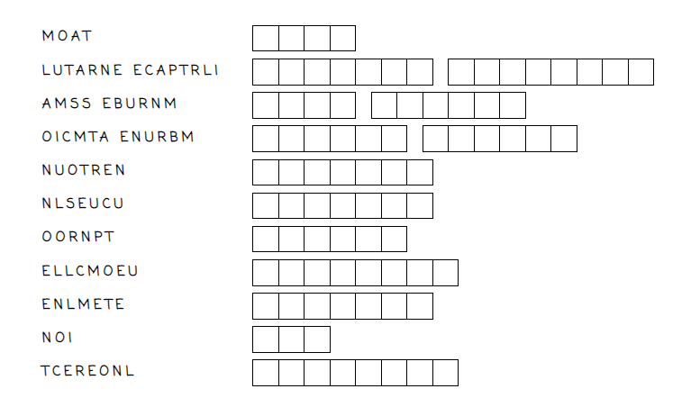

Unscramble the following words

